PRIVATE PPA TERM SHEET
SOLAR PV Rooftop
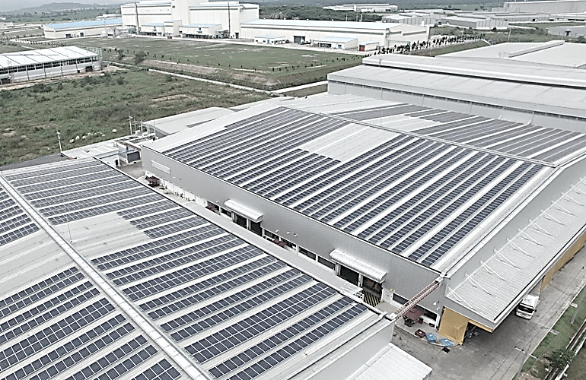
Version 1.3 as of October 31st, 2017
Photo credit: Thai Submit

This Term Sheet has been developed by the USAID Clean Power Asia and GIZ Thailand to facilitate an investment of distributed electricity generation system from Solar PV rooftop in Thailand.

This Term Sheet aims to support market players by providing neutral clauses as a starting point for a negotiation between the Seller and the Purchaser of solar power. We expect that this term sheet can help to reduce soft costs and negotiating time for all interested parties. We encourage the use of this document by all interested parties. The term sheet will be updated periodically to account for changes in government policies, and can be accessible at location http://usaidcleanpowerasia.aseanenergy.org

Private PPA Term Sheet Template
This Term Sheet template has been developed as part of the Solar DPV Implementation Guideline to facilitates the consumer when sending for proposals to Private PPA Developers. The template in outlining the consumer’s general requirement for a Private PPA offer. Please note that all the terms stated below are suggestion and may be redefined as per the consumer’s requirement.

Contract type | Power Purchase Agreement (PPA)
Buyer
Seller
Project
System | Solar PV Rooftop System including Solar PV panels and the balance of system, which includes all components of a PV system such as wiring, switches, a mounting system, one or many solar inverters and control & monitoring system.
Location
Delivered Electricity Unit | Seller shall deliver at minimum the Guaranteed Electricity Delivery Unit to Buyer.
Energy Charge Discount | (Energy Price offered by the Developer)
Energy Charge | (Energy charge Clarification Formula)
Demand Charge | Buyer shall benefit any reduction of Demand Charge
Government Energy Charge | means the tariff that applies to Buyer’s purchase of electricity from the Electricity Authority at that time (including Base Tariff and FT)
Expected Electricity Delivery Unit (kWh) and Guaranteed Electricity Delivery Unit (kWh) | Year Expected Electricity Delivery Unit (kWh) Guaranteed Electricity Delivery Unit (kWh)  1  2  3  4  5  6  7  8  9  10  11  12  13  14  15
Payment | The Buyer agrees to pay the Seller for all Delivered Electricity within the xxxxx (“Payment Due Date”) after the end of the month and the date of receipt of a correct Seller’s invoice, whichever is later.
Project Costs  (any development, investment, installation, maintenance and operational cost in connection with the Project) | Seller shall cover any Costs related to the Project.
Rights to Use Facility’s Rooftop and Transfer of the System | Buyer grants Seller the rights to access, install and operate the System during the term of 15-years Contract without any fee.  After 15 years, Seller shall transfer the System in good condition to Buyer without any fee.
Conditions Precedent | The Conditions Precedent which need to be (i) fulfilled or (ii) waived by xxxx, before the conditional provisions of the PPA (on sale, purchase, delivery and payment of the electricity) enter into force will be specified in the PPA and shall include, without limitation:  - …………………..;
Event of Default | A customary event of default, including non-payment, insolvency, breach of obligations and Delivery Default.
Delivery Default | The Seller cannot deliver the Guaranteed Electricity Delivery Unit to Buyer or there is a Shortfall of the electricity unit
Shortfall Unit | Shortfall Unit = Guarantee Electricity Unit – Delivered Electricity Unit
Liquidated Damages | The positive difference between Government Energy Charge in respect of Guarantee Electricity Unit which fail to be delivered and the Energy Charge multiplied by the Shortfall Unit.
Remedies | If an Event of Default occurs and continues, the defaulting Party shall compensate the non-defaulting Party for any loss incurred as a result of such Event of Default which loss shall in case of a Delivery Default be deemed to be equal to the Liquidated Damages.
Step-in Rights | If Seller fails to compensate Buyer with regards Liquidated Damages, Buyer may carry out, or arrange to carry out any or all of operation and maintenance of the System, and recharge all costs and expenses incurred by Buyer in connection with the same to Seller. During the Step-in Rights period, Buyer shall not pay Seller any Energy Charge.  If Delivery Default occurs and continues for more than a year, Buyer may have the Right to take over the System from the Seller.  Seller irrevocably grants to Buyer all of the necessary power and authority to act on its behalf and shall provide all necessary assistance and cooperation required by Buyer in order to give full effect to the provisions of above.
Force Majeure | The occurrence of any event or circumstance beyond the control of a Party that could not, after using all reasonable efforts, be overcome and which makes it impossible for that Party to perform its obligations under the PPA.
Currency | THB (Thai Baht)
Indemnity | Seller shall indemnify Buyer against any damages (unless resulting from the Buyer's gross negligence or wilful misconduct).
Dispute resolution | Arbitration under the Rules of Arbitration of the International Chamber of Commerce. Three arbitrators. English language. Seat of arbitration is Bangkok and the physical hearings in Bangkok.
Governing law | Thai law.
Confidentiality | The Parties shall treat the contents of the Contract and any other information directly or indirectly related to the PPA (the “Confidential Information”) as confidential. Confidential Information may only be disclosed:  - with the other Party’s prior written consent;  - by a Party to its directors, employees, affiliates, agents, professional advisers, bank or other financing institution, rating agency or intended assignee where necessary to fulfil the tasks under this Term Sheet;  - to comply with any applicable law, regulation, or rule, or in connection with any court or regulatory proceeding; provided that each Party shall, to the extent practicable and permissible under such law, regulation, or rule, use reasonable efforts to prevent or limit the disclosure and to give the other Party prompt notice of it;  - if it is already in the public domain;  - if it needs to be disclosed in order to perform the terms of this Term Sheet.
Termination | - In case of Event of Default continuing for 20 calendar days: possibility to terminate with 20 calendar days notice period.  - In case of bankruptcy event: possibility to terminate immediately.  - In case of Illegality: possibility to terminate at any time.

